
Copying with PaperCut®

How to copy using PaperCut in the Library and ITS

Step 1: Press “Copy” on the Printer touch screen

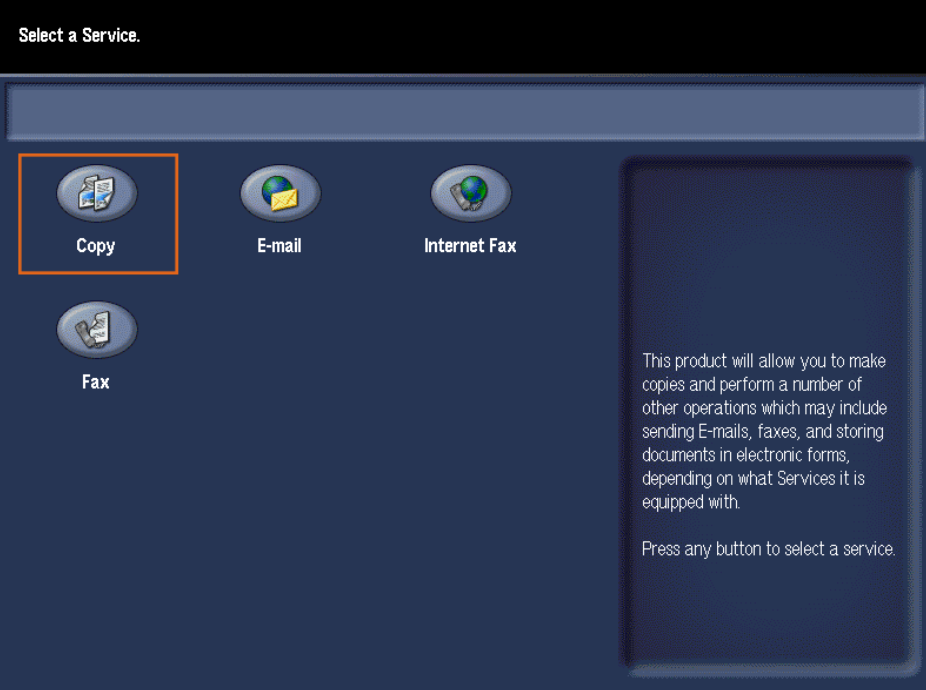

Step 2: Swipe FOB on the FOB reader

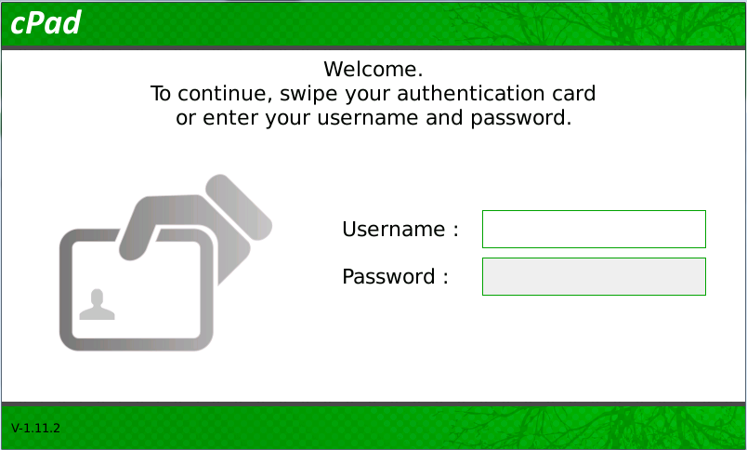

Step 3: Select options for copying on the Printer touch screen

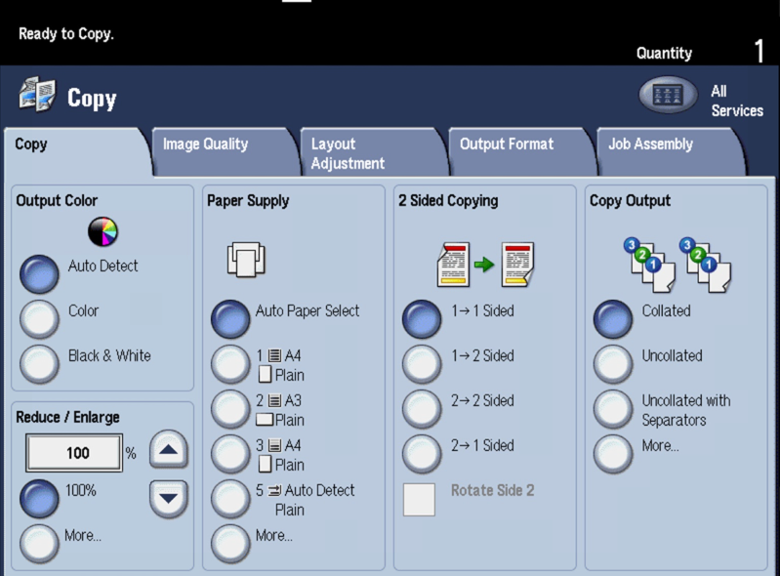

Step 4: Press the “Start” button on the printer

